**Project Design Phase-II**

**Technology Stack (Architecture & Stack)**

|  |  |
| --- | --- |
| Date | 23 October 2022 |
| Team ID | PNT2022TMID19635 |
| Project Name | Project – IoT Based Safety Gadget for Child Safety Monitoring and Notifications. |
| Maximum Marks | 4 Marks |

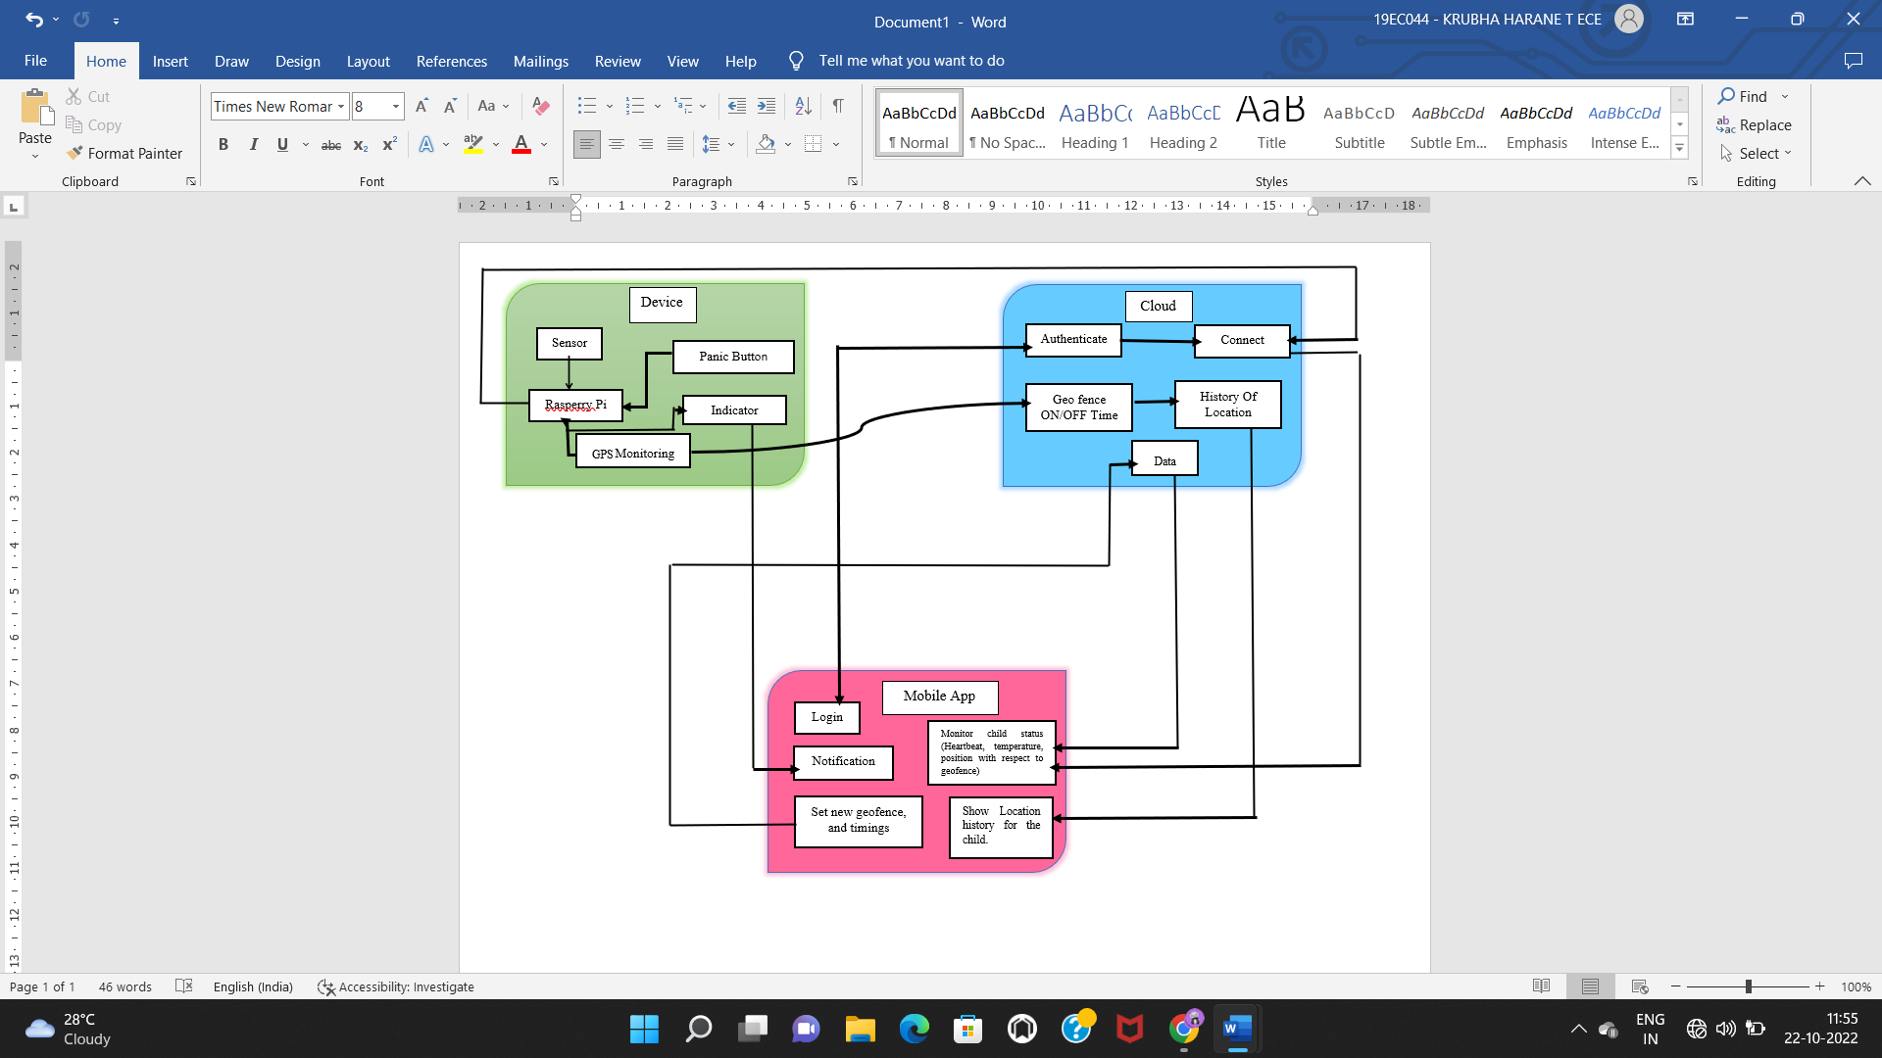

**Table-1: Components & Technologies:**

|  |  |  |  |
| --- | --- | --- | --- |
| **S.No** | **Component** | **Description** | **Technology** |
|  | User Interface | Mobile App. | MIT App Inventor |
|  | Application Logic-1 | Code development phase | Python |
|  | Application Logic-2 | Interfacing purpose | IBM Watson Assistant |
|  | Cloud Database | Database service on Cloud | IBM Cloudant |
|  | File Storage | IBM Cloud Storage usage. | IBM Block Storage |
|  | Browser based flow editor | Visual Programming | Node Red |
|  | Infrastructure (Server/Cloud) | Deploying an Application on a Local Server | Cloud Platform |

**Table-2: Application Characteristics:**

| **S.No** | **Characteristics** | **Description** | **Technology** |
| --- | --- | --- | --- |
|  | Open-Source Frameworks | A social network created a software development template. | IBM Watson Platform, Node Red. |
|  | Security Implementations | Data in the cloud is protected from unauthorised access by login and authentication. | IBM Cloud. |
|  | Scalable Architecture | The mobile app will serve as a conduit in between parent and the gadget in the presentation tier.  The data gathered by the sensor and GPS will be collected by the Logic Tier (Raspberry Pi) and delivered to the cloud.  Data Tier (Cloud): The data will be stored and sent to the mobile application. | Mobile App, Rasperry Pi, IBM Cloud. |
|  | Availability | always logged into the cloud. | IBM Cloud. |
|  | Performance | capable of periodically sending the child's position, and the sensor will periodically report the child's biometrics to the app. | Rasperry Pi, Mobile App. |